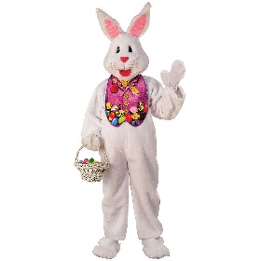
Κάνω επανάληψη του Simple Past, διασκεδάζοντας.
(Δεν χρειάζεται να στείλετε τις απαντήσεις. Με το “Check”, ελέγχετε αν είναι σωστό και με το “Show” βλέπετε το σωστό.)
- Verb to be
https://www.perfect-english-grammar.com/past-simple-exercise-7.html
- Other verbs
https://www.perfect-english-grammar.com/past-simple-exercise-8.html
https://www.perfect-english-grammar.com/past-simple-exercise-9.html

For your free time, I recommend to you:
- Videos:

- https://www.youtube.com/watch?v=cZ4gQniUVO8

- https://www.youtube.com/watch?v=bkNTU_Vv5Ew

- https://www.youtube.com/watch?v=0PSgoPdKQFQ

- https://www.youtube.com/watch?v=lfBn-Nvidto
- https://www.youtube.com/watch?v=onnEaINBaGg

- https://www.youtube.com/watch?v=fhE6ELj2kVM

- https://www.youtube.com/watch?v=8LhWLz43nQE

- https://www.youtube.com/watch?v=v1kRZB0Tc_k

- Easter stories to read:

- http://www.apples4theteacher.com/holidays/easter-fun/short-stories/

- http://www.apples4theteacher.com/holidays/easter-religious/kids-books/

Happy Easter!!!

