Α. Συμπληρώστε στα κενά με: am, is, are
- This an animal school.
- I so excited.
- Cole, my friend, you right.
- My tummy full with red cherries.
- They yummy!
- Your cellar full.
- I still hungry.
- Summer hot.
- The magic things in the bedroom.
- We pirates.

Β. What is he/she/it doing now?
- He is running.

2. She
3. He

4. She

5. He

6. He
7.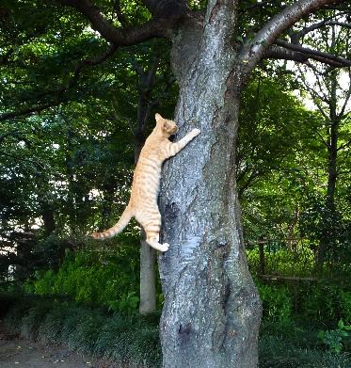 It

