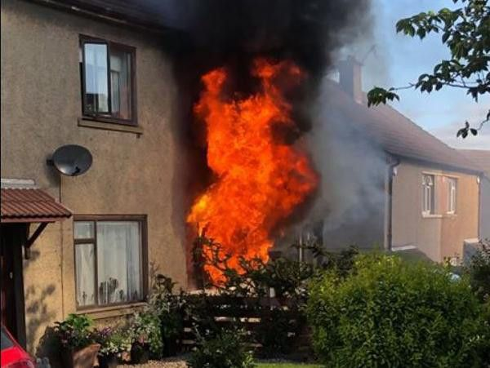
- Write what they were doing when the fire broke out:

1. Jack

2. Jenny

3. Billy
4. Father

5. Mother

6. Grandpa

7. 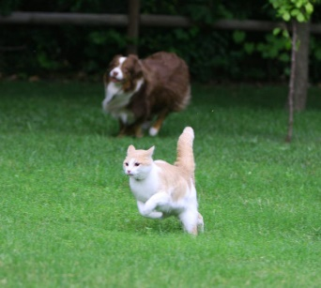 The dog

- Find a suitable question:
1.
Yes, they were flying.
2.
No, they weren’t. They were dancing.
3.
Yes, I was studying History.
4.
No, he wasn’t. He was playing basketball.
5.
No, I didn’t but I called Mary.

