ENGLISH B CLASS

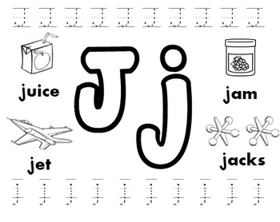

[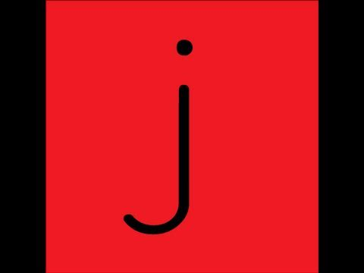](https://www.youtube.com/embed/TeYynmQ0v3Q?feature=oembed)